Sample Text:

"I can't believe she got promoted over me. It's because she's a woman, isn't it? This company is so biased towards women."

Data Collection and Preparation:

Enhanced Data Collection:

Utilizing advanced web scraping tools and APIs, we can collect a diverse range of user-generated content from online platforms known for misogynistic expressions. This could include forums, social media platforms, and comment sections of websites where misogynistic language is prevalent. We'll use tools like Beautiful Soup for web scraping and relevant APIs provided by platforms for data extraction.

Data Augmentation:

After collecting the data, we meticulously clean it to remove noise, errors, and irrelevant content. We'll implement techniques like data synthesis and augmentation to enhance the dataset's diversity and size. This involves techniques such as synonym replacement, back translation, and adding noise to text. Let's augment our sample text using synonym replacement:

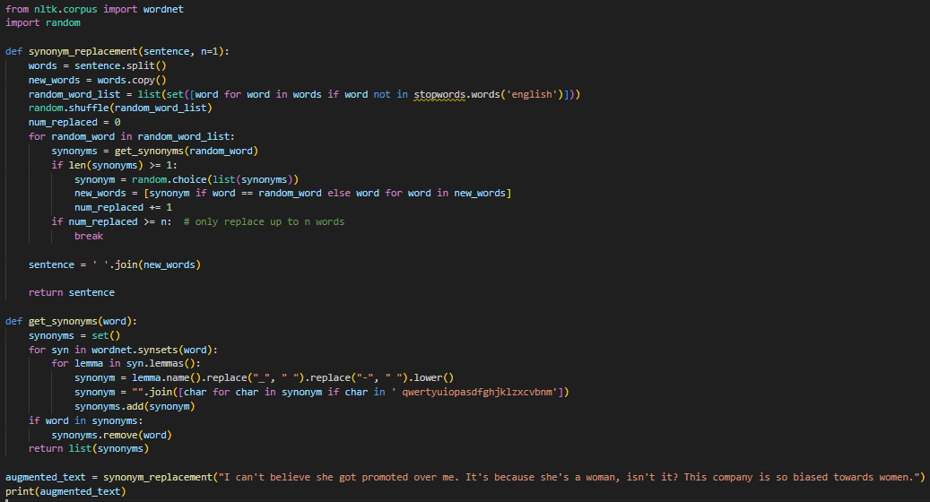

Privacy Preservation:

Implementing state-of-the-art anonymization techniques to protect the privacy of individuals contributing to the dataset is crucial. Techniques like differential privacy or tokenization can be used to anonymize data while retaining its utility for analysis.

Machine Learning Techniques:

Advanced Topic Modeling:

Implementing cutting-edge topic modeling algorithms like Latent Dirichlet Allocation (LDA) or Non-Negative Matrix Factorization (NMF) can help in more nuanced thematic clustering of misogynistic expressions. Let's apply LDA to our dataset to extract topics:

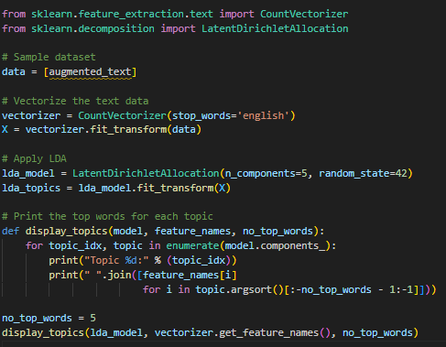

Deep Learning Models:

Exploring the use of deep learning architectures such as Recurrent Neural Networks (RNNs) or Transformer models like BERT can provide more sophisticated linguistic analysis. Let's use a pre-trained BERT model to classify our text:

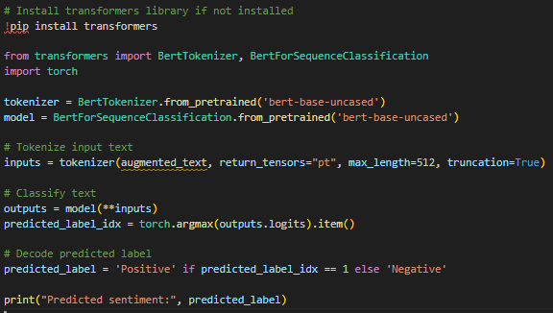

Transfer Learning:

Leveraging pre-trained language models like GPT-3 or RoBERTa for transfer learning can boost model performance on misogynistic language detection. Let's use a pre-trained GPT-3 model for text generation:

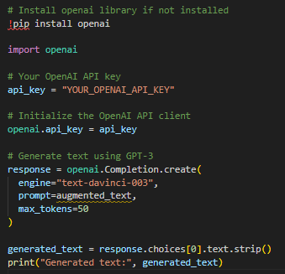

Sentiment and Toxicity Analysis:

Sentiment Analysis:

Utilizing the VADER tool for sentiment analysis on the top 10 most discussed misogynistic topics can help categorize sentiments as positive, negative, or neutral. Let's perform sentiment analysis on our augmented text:

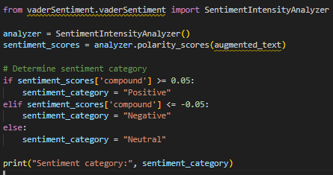

Fine-Grained Sentiment Analysis:

Implementing sentiment analysis techniques beyond VADER, such as LSTM-based models, can capture subtle emotional nuances in misogynistic content.

Custom Toxicity Detection:

Developing a custom toxicity detection model tailored to identify specific forms of harmful and offensive content prevalent in online misogyny.

Toxicity Analysis:

Employing the Google Perspective API for toxicity analysis can help identify harmful or offensive content within misogynistic expressions. Let's use the Perspective API to analyze toxicity:

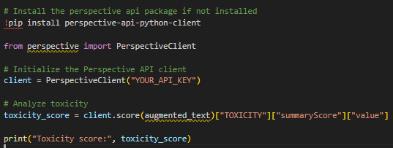

Model Refinement and Evaluation:

Continuous Learning:

Implementing online learning strategies to continuously update models with new data ensures adaptability to evolving forms of online misogyny. We can periodically retrain our models with fresh data and fine-tune hyperparameters to maintain their effectiveness over time.

Data Integration and Analysis:

Integrating sentiment analysis, Named Entity Recognition (NER), and feedback classification results can provide a comprehensive understanding of online misogyny

Evaluation Metrics:

Utilizing comprehensive evaluation metrics like F1-score, precision, recall, and ROC-AUC to assess model performance accurately is crucial. Let's evaluate our sentiment analysis model using F1-score:

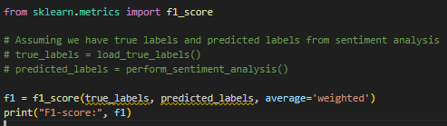

Dashboard Development:

Interactive Visualization:

Creating an interactive dashboard using advanced visualization libraries like Plotly or D3.js can provide stakeholders with intuitive insights into misogynistic discourse trends. Let's create a simple Plotly dashboard to visualize sentiment analysis results:

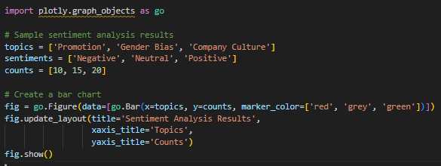

Real-Time Monitoring:

Implementing real-time monitoring capabilities in the dashboard to track changes in online misogyny patterns and facilitate timely interventions is essential. We can use streaming data sources and update the dashboard dynamically. Here's a simplified example using Plotly Dash:

